Linear Algorithmic Search

David Graves
Colorado State University Global
CSC506
Dr. Brian Holbert
March 17, 2025

Linear Algorithmic Search
There are many different types of algorithms that can be leveraged across different scenarios and applications to help power software effectively and efficiently. Some of the more common algorithms that are used when viewing and manipulating large data sets are called collection algorithms which include searching algorithms, sorting algorithms and computational algorithms. I’ll evaluate the task of efficiently searching for a specific item in a large online marketplace database, and offer an algorithm fit for purpose based on factors including time complexity and external factors that could influence its execution with the remainder of this paper.
Design and Purpose
In overall complexity I believe that a simple linear algorithm would work well because it can start at the beginning of a list and methodically work through all entries and return the identified value as soon as found or return a null entry once the list is exhausted if the target entry isn’t located. Understanding that “the time complexity of an algorithm represents the amount of time required by the algorithm to run to completion” (tutorialspoint.com, 2020) can also help inform how to write the Python script more efficiently and represents one of my main concerns with this effort. Depending on the size of the marketplace, the program could run for quite a while if there are many items in the database making it inefficient for large data sets. Considering the list that I drafted for the scenario above only contains six items, the following linear algorithmic search code should be fit for purpose. I’ll briefly discuss a possible way to leverage the solution for larger data sets like online marketplaces later as I reflect on the exercise.
I’ve included the source code in Image 1 that includes two scenarios for target item searches from the ‘item list’. I’ve also added Image 2 below that shows the terminal output of the program where both the first scenario listed ‘hats’ is returned correctly, and the second scenario where ‘sweaters’ is correctly identified as not present in the list “marketplace_items”.
Image 1 – Linear Search Algorithm Source Code
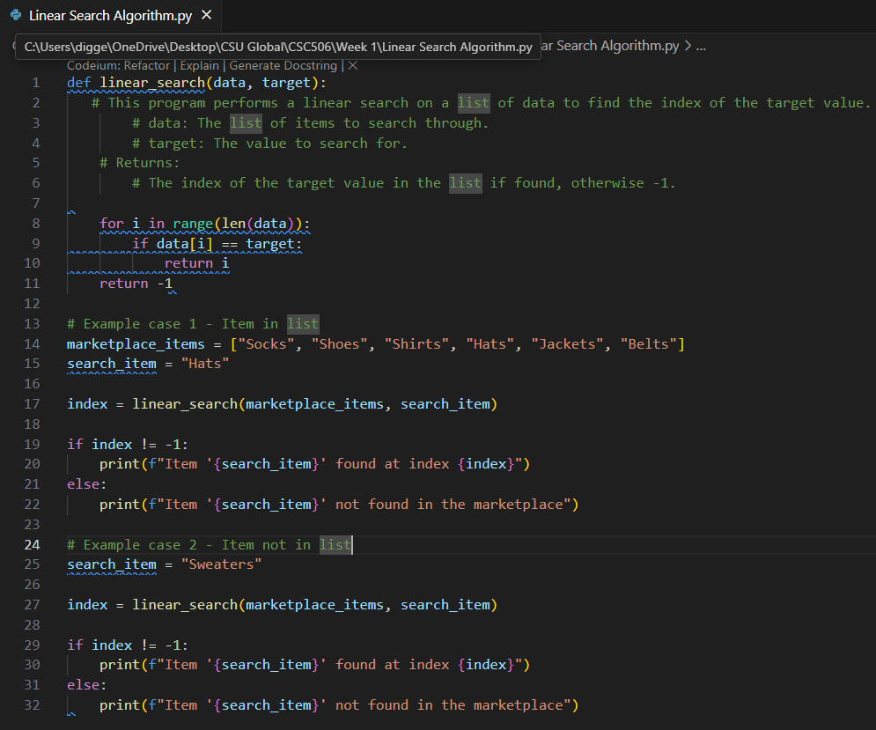
Image 2 – Linear Search Algorithm Terminal Output
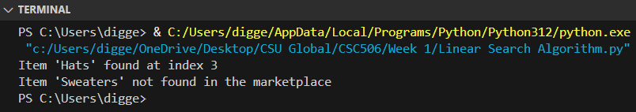
Reflection
This exercise proved a good challenge specifically for thinking through how to structure an algorithm to fit a specific scenario, in this case searching a list for a specific entry. Although the solution I provided would work great with lists in general and especially small data sets, I now have a better appreciation for time and space complexity specifically when considering larger lists like one might find with an online marketplace. I clearly see that this approach may need to be abandoned all together or altered in cases of extremely large lists where additional steps should be considered. Jim Mischel (2015) shared one possible solution to this problem that would allow the simple linear algorithmic code to be used by “buffering data as it comes in and sorting in parallel if you have enough horsepower”. This approach is not infinitely scalable, but it allows one to break the large data set apart and leverage multiple machines to evaluate it in chunks. Personally, I’ll take away a better understanding of the purpose and constraints of linear algorithms when used to search lists from this exercise.

References
Mischel, Jim (2015, February 23). Stackoverflow.com. Searching and sorting large data set.
https://stackoverflow.com/questions/28666310/searching-and-sorting-large-data-set
Tutorialspoint. (2025). Tutorialspoint.com. Data Structures – Algorithms Basics.
Data structures – Algorithms basics

